- The processes should execute in SJF manner to get the lowest waiting time.

Starvation and Aging in Operating Systems
It is one of the most common scheduling algorithms in batch systems. Each process is assigned a priority. Process with the highest priority is to be executed first and so on.
In this post we will discuss a major problem related to priority scheduling and it’s solution.
Starvation or indefinite blocking is phenomenon associated with the Priority scheduling algorithms, in which a process ready to run for CPU can wait indefinitely because of low priority. In heavily loaded computer system, a steady stream of higher-priority processes can prevent a low-priority process from ever getting the CPU.
There has been rumors that in 1967 Priority Scheduling was used in IBM 7094 at MIT , and they found a low-priority process that had not been submitted till 1973.
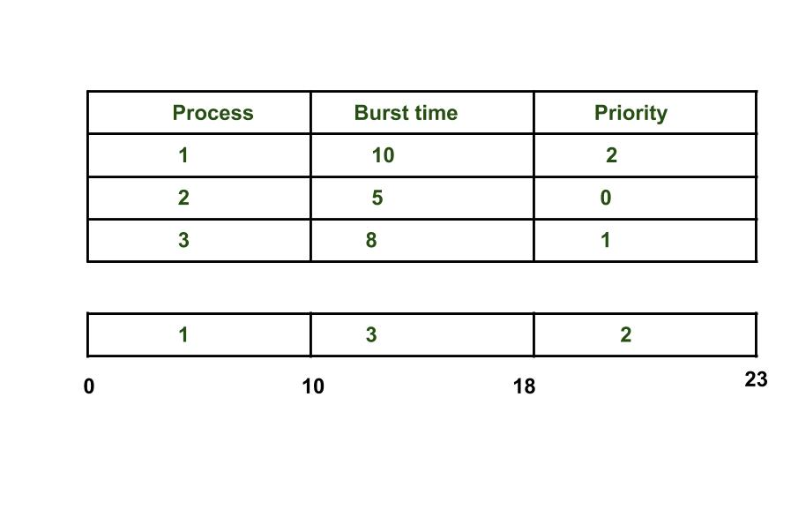As we see in the above example process having higher priority than other processes getting CPU earlier. We can think of a scenario in which only one process is having very low-priority (for example 127) and we are giving other process with high-priority, this can lead indefinitely waiting for the process for CPU which is having low-priority, this leads to Starvation. Further we have also discuss about the solution of starvation.
Differences between Deadlock and Starvation in OS :
- Deadlock occurs when none of the processes in the set is able to move ahead due to occupancy of the required resources by some other process as shown in the figure below, on the other hand Starvation occurs when a process waits for an indefinite period of time to get the resource it requires.
- Other name of deadlock is Circular Waiting. Other name of starvation is Lived lock.
- When deadlock occurs no process can make progress, while in starvation apart from the victim process other processes can progress or proceed.
Solution to Starvation : Aging
Aging is a technique of gradually increasing the priority of processes that wait in the system for a long time.For example, if priority range from 127(low) to 0(high), we could increase the priority of a waiting process by 1 Every 15 minutes. Eventually even a process with an initial priority of 127 would take no more than 32 hours for priority 127 process to age to a priority-0 process.
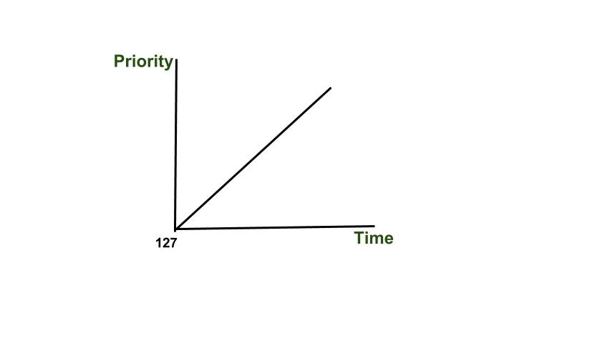

- Lottery Process Scheduling in Operating System
- Lottery Scheduling is type of process scheduling, somewhat different from other Scheduling.
- Processes are scheduled in a random manner. Lottery scheduling can be preemptive or non-preemptive. I
- it also solves the problem of starvation.
- Giving each process at least one lottery ticket guarantees that it has non-zero probability of being selected at each scheduling operation.
In this scheduling every process have some tickets and scheduler picks a random ticket and process having that ticket is the winner and it is executed for a time slice and then another ticket is picked by the scheduler. These tickets represent the share of processes. A process having a higher number of tickets give it more chance to get chosen for execution.
Example – If we have two processes A and B having 60 and 40 tickets respectively out of total 100 tickets. CPU share of A is 60% and that of B is 40%.These shares are calculated probabilistically and not deterministically.
Explanation –
- We have two processes A and B. A has 60 tickets (ticket number 1 to 60) and B have 40 tickets (ticket no. 61 to 100).
- Scheduler picks a random number from 1 to 100. If the picked no. is from 1 to 60 then A is executed otherwise B is executed.
- An example of 10 tickets picked by Scheduler may look like this –
Ticket number - 73 82 23 45 32 87 49 39 12 09.
Resulting Schedule - B B A A A B A A A A.
- A is executed 7 times and B is executed 3 times. As you can see that A takes 70% of CPU and B takes 30% which is not the same as what we need as we need A to have 60% of CPU and B should have 40% of CPU.This happens because shares are calculated probabilistically but in a long run(i.e when no. of tickets picked is more than 100 or 1000) we can achieve a share percentage of approx. 60 and 40 for A and B respectively.
Ways to manipulate tickets –
- Ticket Currency –
Scheduler give a certain number of tickets to different users in a currency and users can give it to there processes in a different currency. E.g. Two users A and B are given 100 and 200 tickets respectively. User A is running two process and give 50 tickets to each in A’s own currency. B is running 1 process and gives it all 200 tickets in B’s currency. Now at the time of scheduling tickets of each process are converted into global currency i.e A’s process will have 50 tickets each and B’s process will have 200 tickets and scheduling is done on this basis.
- Transfer Tickets –
A process can pass its tickets to another process.
- Ticket inflation –
With this technique a process can temporarily raise or lower the number of tickets it own.

